Differential Equation for Ch3-3

Q15

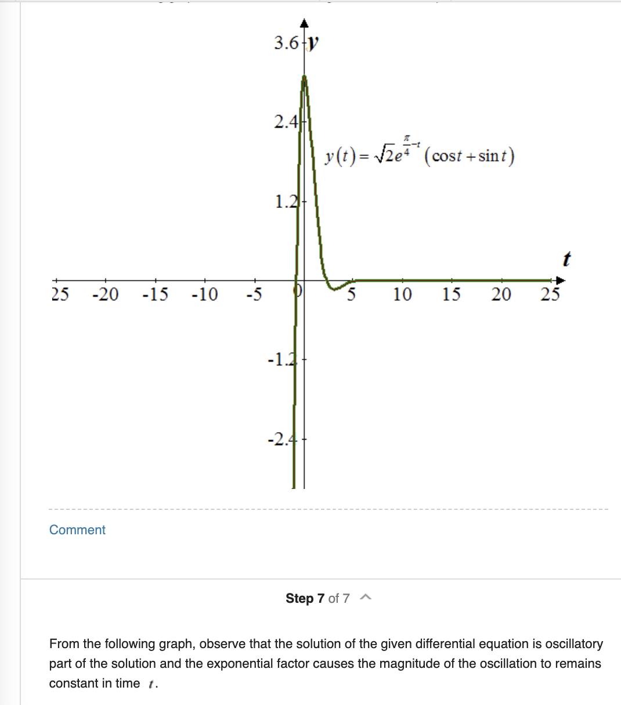

this is the final graph, and note here the conclusion is the function is actually oscillating in large t but overall the magnitude of oscillation does not change.

prove:

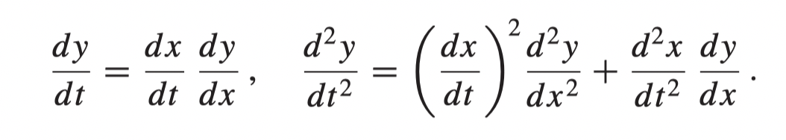

Note that twice differentiation is different from (first differentiation) ^ 2!!